Target Market

The Total Addressable Market, i.e. total market for self-checkout systems which comprises of the supermarkets, hypermarkets and small stores around the world is estimated to be around $4.6 Billion in 2021 and the sector is forecasted to have a growth rate of around 13.3% (CAGR) from 2020 to 2027. The total revenue forecast is estimated to be $7.8 Billion by 2027.

The Serviceable Addressable Market, which comprises the supermarkets and hypermarkets in tier 1 &2 cities in India in our case, is estimated to be around $1-2 Billion by 2027, which we plan to capture in the near future. These higher end supermarkets and hypermarkets would serve as our first customers. We have a lot of growth potential in this sector as the market in our region is still in its infancy, to support this statement; here is the chart that depicts the market share of self-checkout systems.

The Serviceable Obtainable Market which are the high-end markets of India comprise of a total of $400 million right now.

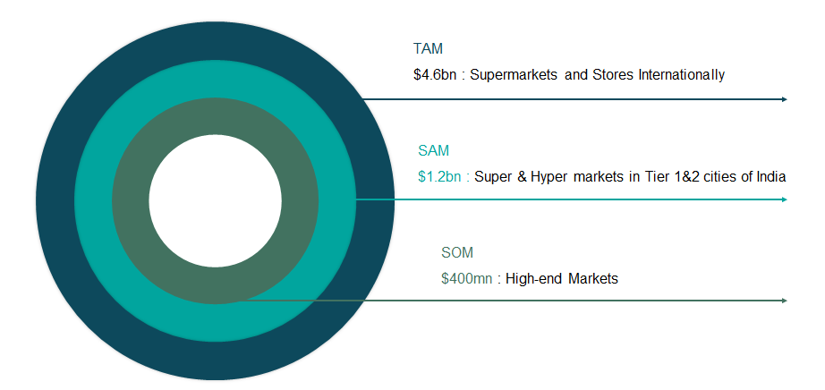 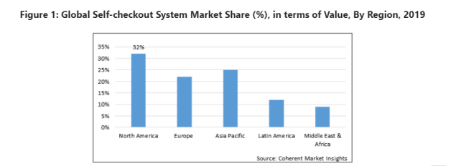Source: <https://www.coherentmarketinsights.com/market-insight/self-checkout-system-market-4366>

Key Partners

Our solution is reliant on utmost support from store owners and their staff for a successful execution of our full-fledged automated checkout system in their corresponding super stores. Primarily, we require manufactures for the customized full size bay cabin. This cabin could be standardized or be moulded based on customer requirements.

Other than that, for high accuracy, we need precision camera manufactures and partners for their manufacturing, assembly and the successful installation of these systems. As the basic technology is Sensor fusion with AI integration, companies with great success in these niches are necessary for good implementation.

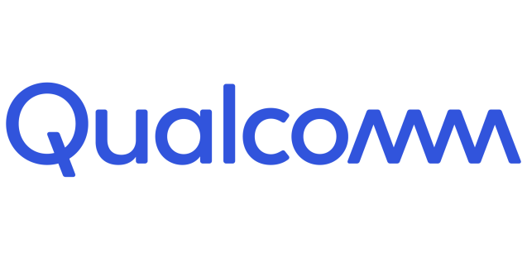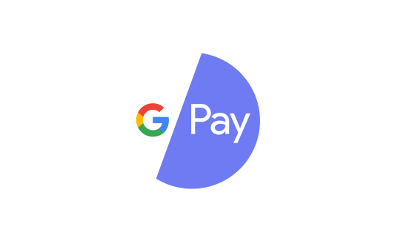We also provide consumer analytics to our customers, and hence storing, updating and modifying data continuously and quickly is essential for which we would require Database Management and Hosting services, along with competent and skilful data analysts. We would also employ several payment gateways Paytm, Google Pay, etc. for hassle-free checkout and a completely automated process.

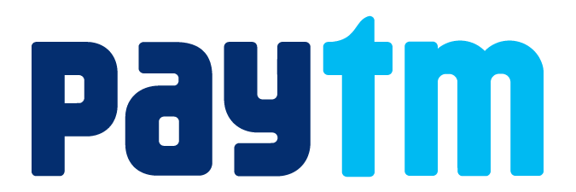

Channels

Our primary channel is to sell the software-integrated hardware for the checkout system directly to our customers. For this, we plan to build professional websites and app which would benefit both, the customers and their consumers.

The website would be the first place of visit to get an insight on our product. Website contains positive feedback and testimonials from customers who are already using our product and increasing their revenue. Chatbots can be used for self-customer care in case of a customer facing some minor issues. Otherwise they can reach out to us through phone calls in case they face a major issue with the checkout system.

Social media marketing strategies along with television commercials would be employed to get a strong kick-start, but word of mouth promotion amongst our customers would attract certain incentives and discount on our subscription plans.

Further, it can be done that the CheckItOut app that would be used by the end consumers would have promotions of other such hypermarkets which have this automated system, thus informing the consumers about more of our clients.